Bahrain – EPEE Men's & Women's Junior & Cadet
FIE World Cup
Individual & Team
15th to & 18th January 2026

TO ALL FENCING FEDERATIONS AND ASSOCIATIONS AFFILIATED WITH THE FIE
We are delighted to invite you to join us at the Bahrain - EPEE Men’s & Women’s Junior & Cadet Individual & Team FIE World Cup, scheduled for 15 – 18 January 2026, in Manama, Kingdom of Bahrain.
Date:
15th to 18th January 2026
Individual & Team
City:
Manama, Bahrain
Venue:
Khalifa Sports City Stadium
Organizers:
Bahrain Fencing Association
Telephone: +973 397 22 719
WhatsApp no. +97333940430
E-Mail: brnfencing@gmail.com

ENTRY: The Men’s & Women's Junior & Cadet FIE World Cup is open to all fencers with a 2025 -2026 FIE license. Inscription must take place on the FIE website, according to the FIE rules and deadlines.

FORMULA:
Individual: One qualifying round of pools, a direct elimination table to qualify for a final by direct elimination.

REFEREES: In accordance with the FIE Rules the number of FIE A or B Grade referees that must accompany teams to competitions is:
1–4 fencers No obligation to provide a referee
5–9 fencers One referee
10 or more fencers Two referees
1 Team One referee according to the FIE rules.

A team of four fencers without a referee will have to pay 1000 € fine to the organizer.
For junior A Grade competition, the name(s) of the referee(s) (who must have an FIE category in the weapon of the competition for which they are entered) must be notified via the FIE website 7 days before the competition (midnight, Lausanne time).

SCHEDULES:
Schedule | Date | Time | Place
Accreditation, Weapon Control | 14/01/2026 | Open At 16:00 | Sports venue
Accreditation, Weapon Control | 15/01/2026 | Open At 08:00 | Sports venue
Accreditation, Weapon Control | 16/01/2026 | Open At 08:00 | Sports venue
Accreditation, Weapon Control | 17/01/2026 | Open At 08:00 | Sports venue
Accreditation, Weapon Control | 18/01/2026 | Open At 08:00 | Sports venue

Schedule | Event | Date | Time | Program
Competition | Cadet | 15/01/2026 | 09:00  13:00 | Men's Individual  Women's individual
Competition | Junior | 16/01/2026 | 09:00 | Men's individual
Competition | Junior | 17/01/2026 | 09:00 | Women's individual
Competition | Junior | 18/01/2026 | 09:00  10:00 | Men’s Team  Women's Team

ENTRY FEE:
An entry fee of 25 € per fencer for an individual and 150 € for the team, will be given to the organizers during Registration.

All the participants: individuals and teams pay CASH to the organizer.

DOPING:
Doping control will be done according to FIE rules.

ACCOMMODATION AND TRANSPORTATION:
We offer to arrange accommodation and airport transfer reservations. You can find the information concerning the official hotels in the below table.
Transportation schedule between the recommended official hotels and the venue of the competition will be arranged and posted in the hotel (each fencer will have the possibility to arrive at least 1 hour before the beginning of his round of pool).
If you have any more concerns related to accommodation and transportation, please contact:

Accommodation, transportation, and all other inquiries email:
brnfencing@gmail.com , WhatsApp no. +973 3394 0430, Tel: +973 3972 2719

ENTRY VISA
To obtain a visa, participants must email a copy of their valid passports along with the entry forms.
For VISA, please share the details via email:
bahrain.fencing@hotmail.com, bahrainfencing@gmail.com

The Organizing Committee will take care of the necessary formalities for obtaining entry visas at Euro 50 per person.

Visa Fees: 50 €

Accommodation:
Competition Official Hotel Rates in Bahrain
On half board (Meals: Breakfast & Dinner)

Wyndham Garden Hotel **** STAR
Single room | Double Room | Triple Room
95 € | 135 € | 165 €

City Center Hotel **** STAR
Single room | Double Room | Triple Room
95 € | 135 € | 165 €

InterContinental Hotel ***** STAR
Single room | Double Room | Triple Room
170 € | 215 € | 255 €

General Privileges and Services:
• Complimentary Internet access in the room (WIFI)
• Complimentary tea and coffee-making facility in the room
• Iron and ironing boards available in the room
• Mineral drinking water per day per room

Hotel Facilities:
• Complimentary access to Hotel Gymnasium, Swimming Pool and SPA, Steam & Sauna rooms
• Complimentary WIFI access in the lobby

All The Mentioned Prices Are Per Room Per Night

Transfers: Airport -Hotel – Sports Venue:
It will cost 35 € per person for transportation between the airport (pick-up and drop-off), sports venue, and accommodation.

Payment:

All the participants/guests can pay CASH to the organizer.

Or

Participating Federations/Associations can send the payment via bank transfer and MUST share the payment advice to
WhatsApp: 00973 3394 0430 or email brnfening@gmail.com

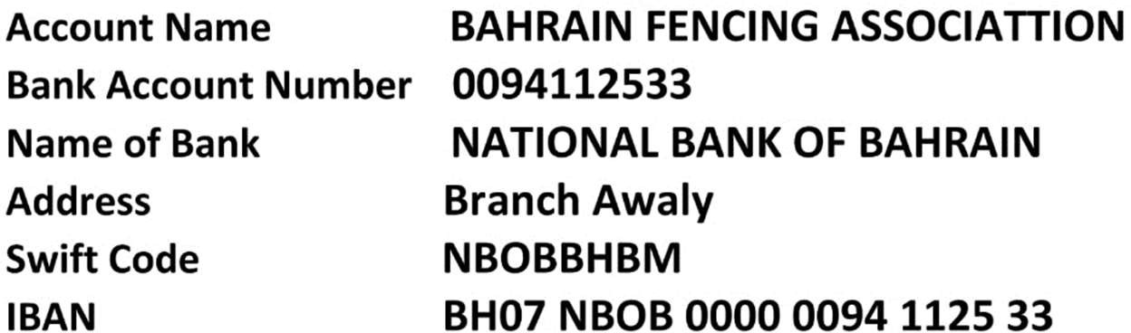

Note: all the payments will be collected by the Organizing Team only.

